**KOVAI.CO ASSESSMENT**

**Task 2: Video Game Sales**

**Exploratory Data Analysis:**

1. Reading the Dataset



1. Examining the Dataset and checking for null values



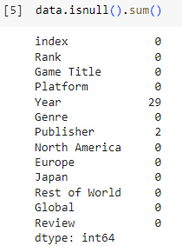

1. Replacing the Null values

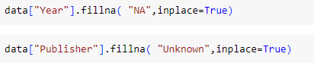

1. Games that are successful



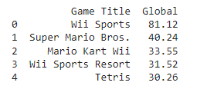

1. Visualizing the game that are successful

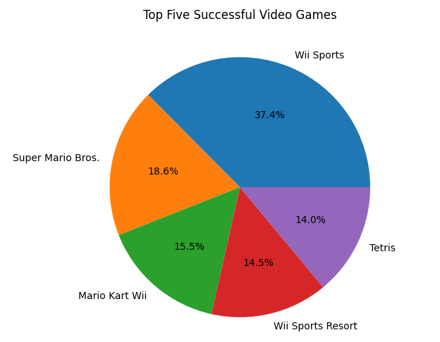

**INSIGHTS:**

1. **Top 10 Genre with the highest rating:**

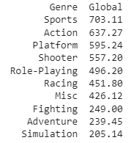

From above figure we can infer that “Sports” genre is liked by many people globally followed by “Action”

1. **The region which play most of the game**

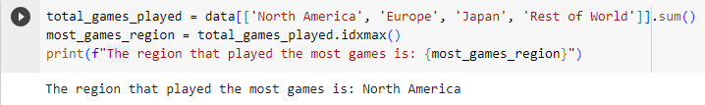

The region which played most of the games is North America

1. **The game and the genre people are least interested**



The least interested game is 'DiRT' in the genre 'Racing' with 0.83 Global sales.

1. **Statistical Analysis of given data**

